How To Join Cooperative Processing
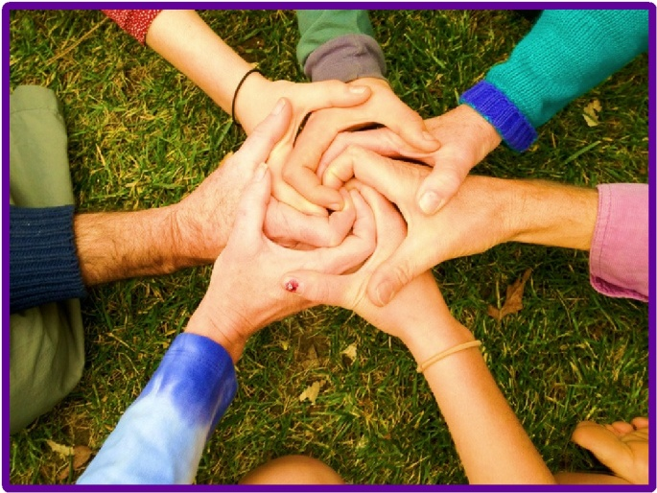
Folks who have taken either an in-person or virtual tour of the Ingenium Expressive Arts Village and would like to further explore the possibility of becoming a resident are invited to come to a Cooperative Processing meeting.
We recognize that at least for the first few months, most newcomers will be in an “Exploration Stage”, learning about the project in depth before deciding whether to make any type of commitment. That being said, in order to ensure that those who are participating in significant decision making are the same people who are most likely to actually live on the land, we ask that all participants follow the steps below. This structure has come about through several years of experience with hosting new and potential members, and was co-created with support through our Cooperative Processing practice:
1st Meeting – People who have just completed the tour are welcome to attend one meeting. Before arriving, they should have already read through the website, especially the “Knowing More About Our Vision” web page, the “FAQ’s” web page, as well as the “How Much Does It Cost To Live At Ingenium” and the other handouts given at the tour. Newcomers are encouraged to participate in check-ins and observe our decision making process during their first meeting.
2nd Meeting – After the first meeting we ask participants to begin carrying out the other residency requirements before attending a second Cooperative Processing meeting.
This can be done by either:
- Completing 2 or more hours of volunteer service (ask for a copy of our “Small Projects” list from your host before you arrive), or
- Organizing and carrying out a special event, or
- Joining or initiating a special project or task committee, or
- Reading the “Creating A Life Together” book and either filling out an assessment questionnaire; organizing a discussion group; or somehow otherwise show that they’ve completed the reading. (Reading this book is optional).
3rd Meeting - Folks should continue their participation at Ingenium in the above ways between the second and third meeting. They can complete 3 or more additional service hours or choose a second task on the above list. They should also begin attending our weekly Residents Meeting as well. They are encouraged to arrange for an overnight stay on the land by this time too.
4th Meeting - By the fourth meeting, the 10 hours of volunteer service should be completed.
5th Meeting - Before their fifth Cooperative Processing meeting prospective members should arrange to stay for their week-long immersion visit. Their special event should be completed by then too. If their experience is positive and they want to continue, they should ask for a residency application.
6th Meeting – By their sixth meeting we expect prospective residents to have formed a committed decision that they want to live at Ingenium, and they should submit their completed application & fee.
>>> Folks who have a desire to become a resident more quickly are welcome to complete the above steps sooner and at their own pace. We do ask that prospective residents attend at least two group Cooperative Processing meetings and two private meetings before acceptance.<<<
● Those who have not completed the tasks outlined above are asked to return to the Cooperative Processing meetings only as each step has been fulfilled. Folks are welcome to take as much or as little time as they need for each step.
At each meeting, we usually have brief individual check-ins and each resident or potential resident is invited to “put something on the table” if they have a question, idea or topic they’d like for the group to attend to together. Often, we either have a practice “Compassionate Communication” activity, work out real-life issues, collaborate on important decisions, or practice consensus on new or developing proposals. Our goal is to operate from a place of mutual support and inspiration, often exploring each other’s feelings, needs and viewpoints as our own. We also encourage the practice of shared leadership roles.
Cooperative processing generally takes place the first Tuesday evening of the month, either via Zoom or downtown Nevada City. Each meeting usually lasts about three hours. Do let us know if you plan to attend. This is important because sometimes the date and/or time of the meeting changes. The meetings are hosted and co-facilitated by Peter Cohen, certified Compassionate Communication (NVC) and consensus trainer. We graciously contribute $60 per hour for Peter’s time, energy and expertise, which is split among everyone who attends each meeting.

